Your Name : Muhammad Shahbaz(21L-7525), Fasih Saqib(21L-5430),Mohib(21F-9054)

Subject Name : Software design and Analysis

Section: BCS-5A

**Requirement Analysis**

**Functional Requirements:**

**1. User Management:**

- Sign Up: Admin, team leaders, and team members can create accounts with unique credentials.

- Login: Users can securely log in to their respective accounts.

**2. Task Management:**

- Track Task: Team leaders and members can track the progress of tasks assigned.

- View Task: Team leaders and members can view details of tasks, including status and assignments.

- Priority and Deadline: Users can assign priority levels and deadlines to tasks for efficient management.

**3. Team Management:**

- Add Team Leader: Admin can appoint team leaders and assign relevant permissions.

**4. Analytics:**

- Analytics: Admin and team leaders can access analytical data for performance evaluation and planning.

**5. Reminder Management:**

- Receive Reminder: Team members and leaders receive automated reminders for pending tasks and deadlines.

- Send Reminder: Team leaders can send reminders to team members for overdue tasks.

**6. Search and Filtering:**

- Search and Filtering: Users can search for specific tasks, projects, or team members. Filtering options based on various criteria are available for efficient task retrieval.

**Non-Functional Requirements:**

**1. Security:**

- User data and login credentials must be encrypted to ensure secure access.

- Access control mechanisms should be in place to restrict unauthorized access to sensitive information.

**2. Performance:**

- The system should be responsive, ensuring quick loading of data and tasks.

- The analytics module should provide real-time data for effective decision-making.

**3. Reliability:**

- The system should be available 24/7, with minimal downtime for maintenance or updates.

- Data integrity should be maintained; tasks and user information should not be lost or corrupted.

**4. Usability:**

- The user interface should be intuitive and user-friendly, catering to users with varying technical expertise.

- Clear and concise error messages should guide users in case of incorrect inputs or system failures.

**5. Scalability:**

- The system should be scalable to accommodate a growing number of users, tasks, and teams without compromising performance.

The above **requirement analysis** ensures that the system meets the **functional needs of the three user roles** (admin, team leader, and team member) while also **addressing key non-functional aspects** such as security, performance, reliability, usability, scalability, and compliance.

**Use Case**

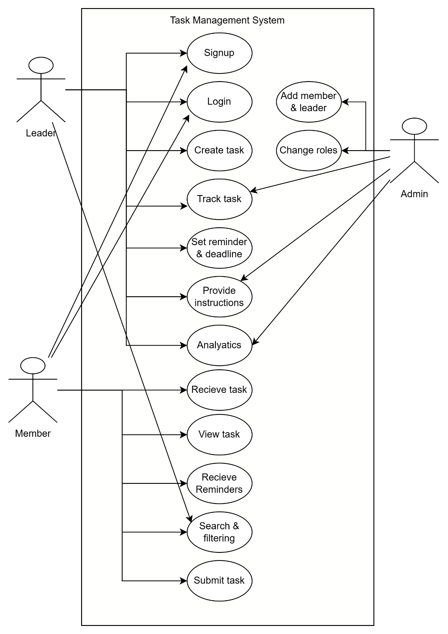

**Use Case Specification:**

**Use Case 1:Sign Up:**

- Actors: Admin, Team Leader, Team Member

- Description: Users can create an account by providing necessary information.

- Preconditions: None

- Postconditions: User account is successfully created.

- Main Flow:

1. User selects the "Sign Up" option.

2. User enters personal information and credentials.

3. System validates information.

4. User account is created and confirmed.

**Use Case 2: Login**

- Actors: Admin, Team Leader, Team Member

- Description: Users can securely log in to their accounts.

- Preconditions: User account exists.

- Postconditions: User is logged into the system.

- Main Flow:

1. User enters username and password.

2. System validates credentials.

3. If valid, user is logged in; if not, appropriate error message is displayed.

**Use Case 3: Track Task**

- Actors: Team Leader, Team Member

- Description: Users can monitor the progress of assigned tasks.

- Preconditions: User is logged in.

- Postconditions: Task status and progress are displayed.

- Main Flow:

1. User selects the "Track Task" option.

2. User views task details, including status and assignments.

**Use Case 4: View Task**

- Actors: Team Leader, Team Member

- Description: Users can view detailed information about tasks.

- Preconditions: User is logged in.

- Postconditions: Task details are displayed.

- Main Flow:

1. User selects the "View Task" option.

2. User specifies task criteria (if any).

3. System displays relevant task details.

**Use Case 5: Priority and Deadline**

- Actors: Team Leader, Team Member

- Description:Users can set priority levels and deadlines for tasks.

- Preconditions: User is logged in and viewing a specific task.

- Postconditions: Task is updated with new priority and deadline.

- Main Flow:

1. User selects a task.

2. User sets priority levels and deadlines.

3. System updates task information.

**Use Case 6: Add Team Leader**

- Actors: Admin

- Description: Admin can appoint team leaders and assign permissions.

- Preconditions: Admin is logged in.

- Postconditions: New team leader is added with specified permissions.

- Main Flow:

1. Admin selects the "Add Team Leader" option.

2. Admin enters team leader's information and assigns permissions.

3. System confirms addition of new team leader.

**Use Case 7: Analytics**

- Actors: Admin, Team Leader

- Description: Users can access analytical data for performance evaluation and planning.

- Preconditions: User is logged in.

- Postconditions: Analytical data is displayed.

- Main Flow:

1. User selects the "Analytics" option.

2. User specifies criteria for analytics (if any).

3. System generates and displays analytical data.

**Use Case 8: Receive Reminder**

- Actors: Team Leader, Team Member

- Description: Users receive automated reminders for pending tasks and deadlines.

- Preconditions: User is logged in.

- Postconditions: Reminder is sent to the user.

- Main Flow:

1. System checks pending tasks and deadlines.

2. System sends automated reminders to relevant users.

**Use Case 9: Send Reminder**

- Actors: Team Leader

- Description: Team leaders can send reminders to team members for overdue tasks.

- Preconditions: User is logged in and viewing task details.

- Postconditions: Reminder is sent to specified team members.

- Main Flow:

1. User selects a task with overdue status.

2. User sends a reminder specifying task details.

3. System sends reminders to team members.

**Use Case 10: Search and Filtering**

- Actors: Admin, Team Leader, Team Member

- Description: Users can search for specific tasks, projects, or team members. Filtering options are available for task retrieval.

- Preconditions: User is logged in.

- Postconditions: Filtered results are displayed.

- Main Flow:

1. User enters search criteria or selects filtering options.

2. System processes the query and displays filtered results.

**Use Case 11: Change User Roles**

-Actors: Admin

-Description: Admin can change the roles of team members and team leaders.

-Preconditions: Admin is logged in.

-Postconditions: User roles are updated as per the admin's instructions.

-Main Flow:

1.Admin selects the "Change User Roles" option.

2.Admin specifies the user whose role needs to be changed.

3.Admin selects the new role (Team Leader, Team Member, or Admin).

4.System updates the user's role accordingly.

**Use Case 12: Submit Task**

-Actors: Team Member

-Description: Users can submit completed tasks for review.

-Preconditions: User is logged in and assigned a task.

-Postconditions: Task is marked as submitted for review.

-Main Flow:

User selects the "Submit Task" option.

User chooses the task they want to submit.

User attaches any necessary files or comments for the review.

System marks the task as "Submitted" and notifies the relevant parties for review

**Use Case 13: Instruction for Making Changes to a Submitted Task:**

-Actors: Team Member

-Description: This use case outlines the steps a team member should follow if they need to make changes to a task that has already been submitted for review.

-Preconditions:

You are logged into your account.

You have submitted a task for review.

You need to make changes to the task.

-Postconditions:

The task is updated with the changes.

-Main flow

The task is updated with the changes.

Log in to your account.

Find the submitted task in the task management section.

Click on the task to open its details.

Look for an "Edit" or "Make Changes" option.

Update the task with the necessary revisions.

Save the changes.

If available, select "Resubmit" to indicate the revised version.

The task will now be updated with the new information.

**Activity diagram**

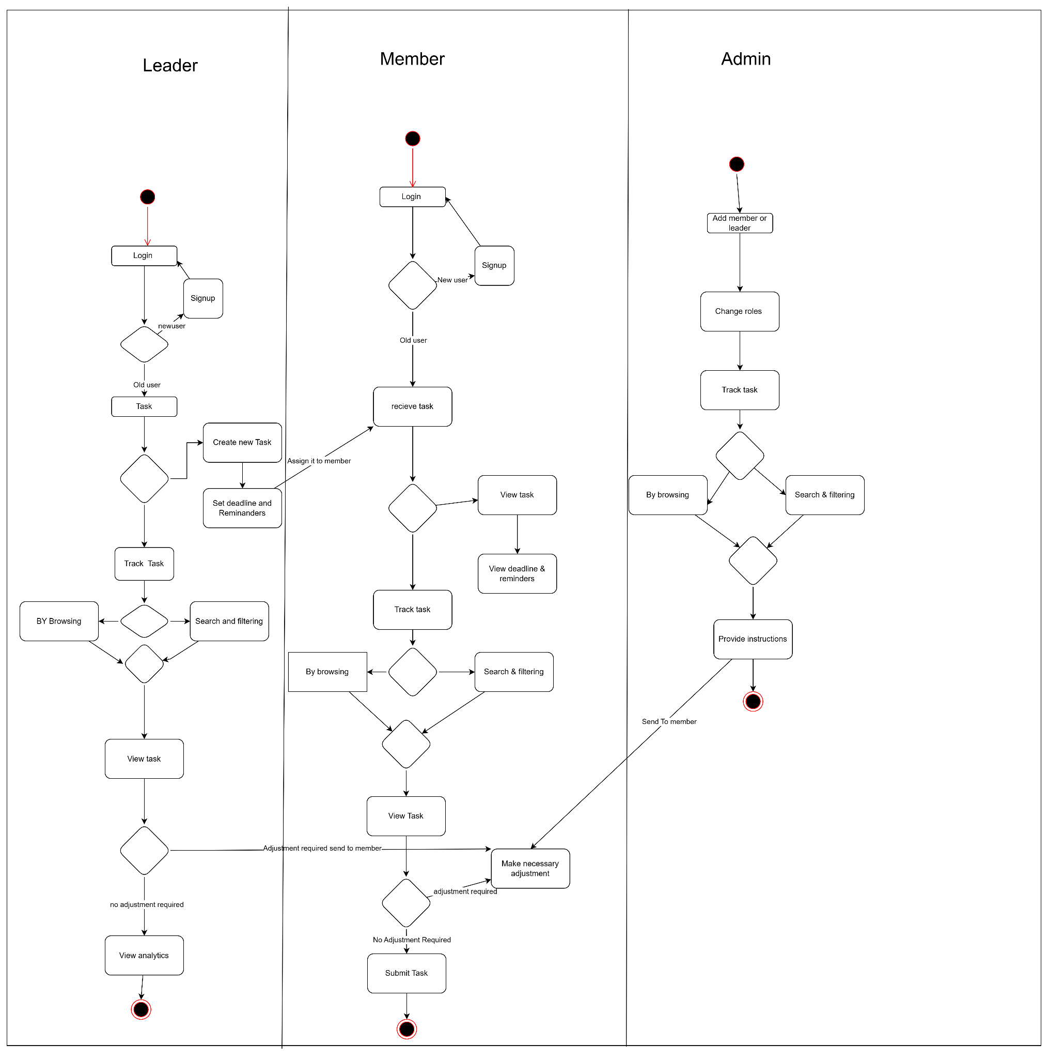

**State diagram**

**Member**

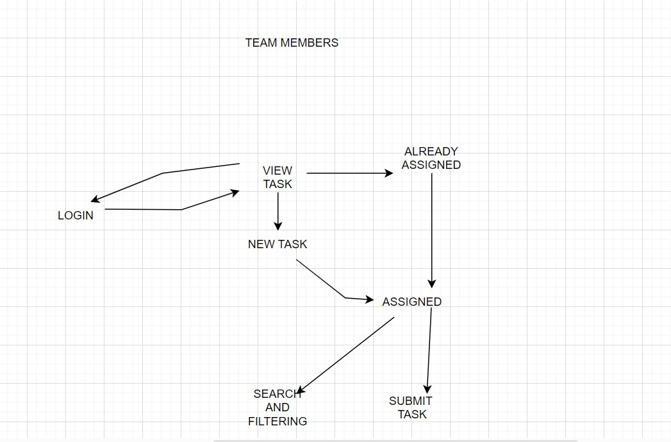

**Leader**

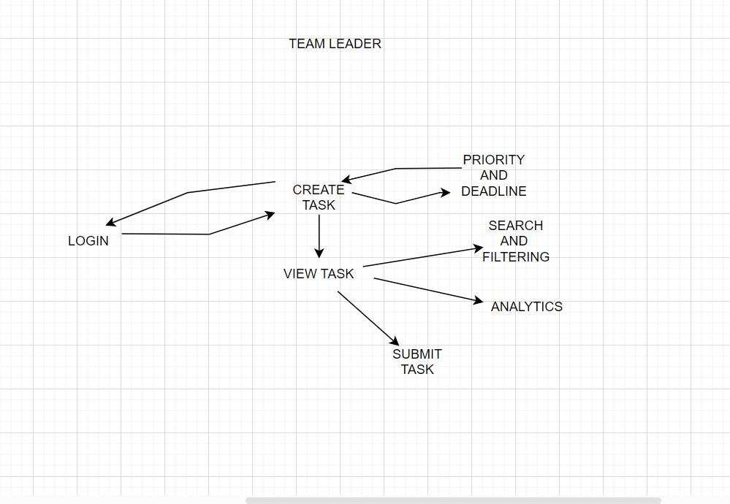

**ADMIN**

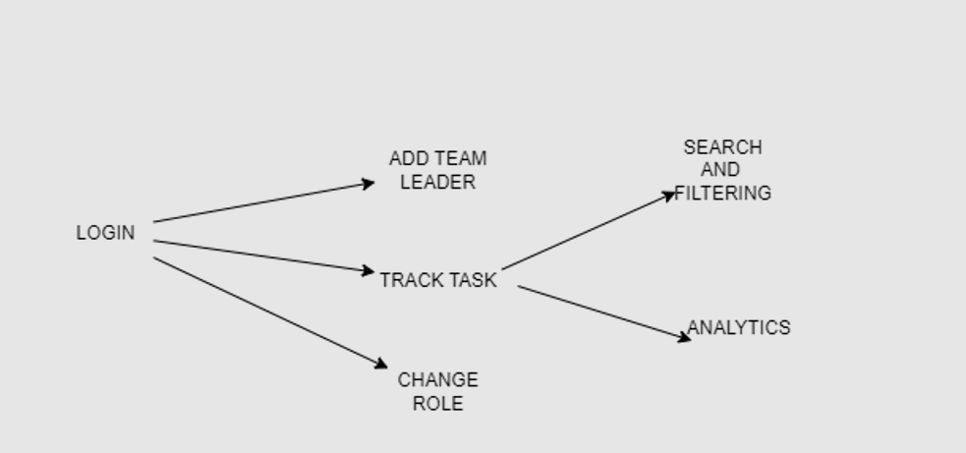

**Domain model**

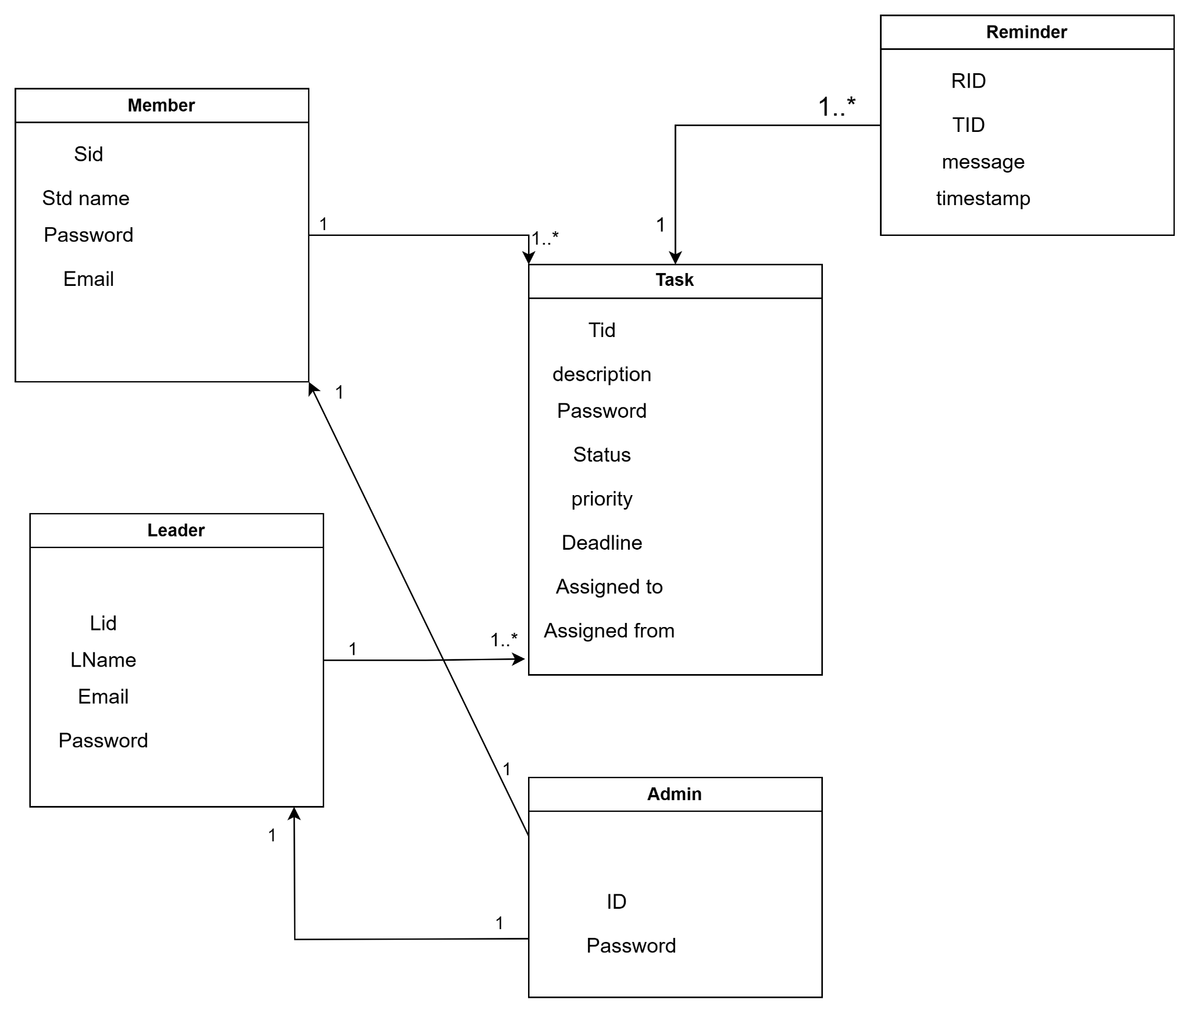

**Architecture diagram**

